**To count no. of zeroes and ones of a hexadecimal number.**

CODE:

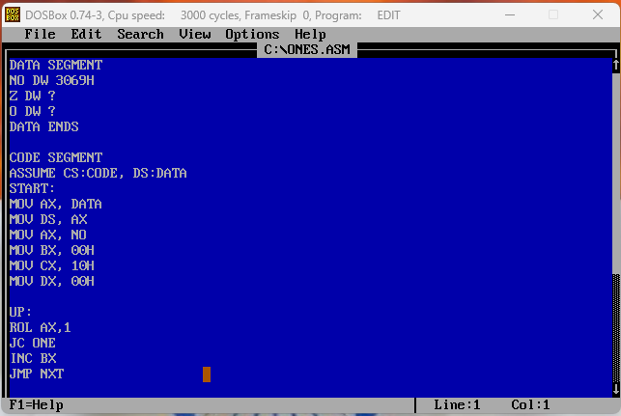

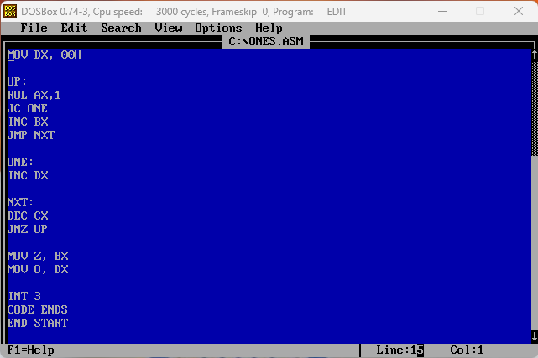

OUTPUT:

